|  |  |
| --- | --- |
| **WC Logo.emf** | **Staff Report to the Weber County Commission**  *Weber County Planning Division* |
|  | |

****Synopsis****

****Application Information****

**Application Request:** Request for final approval of Westwood Homestead Subdivision, consisting of four lots and road dedication along 1900 North St.

**Type of Decision: Administrative**

**Agenda Date: Tuesday, November 02, 2021**

**Applicant: Westwood Eden, LLC**

**Representative:** Mike Westwood, Owner

**File Number:** UVW06062021

****Property Information****

**Approximate Address:** 1900 N 7800 E, Eden, UT, 84310

**Project Area:** 14.1702 acres

**Zoning:** Forest Valley (FV-3), Agricultural Valley (AV-3)

**Existing Land Use:** Agriculture

**Proposed Land Use:** Residential

**Parcel ID:** 21-005-0030

**Township, Range, Section:** T6N, R2E, Section 16 S

****Adjacent Land Use****

**North:** 1900 North St. **South:** Residential

**East:** 7800 East St. **West:** Residential

****Staff Information****

**Report Presenter: Tammy Aydelotte**

**taydelotte@webercountyutah.gov**

**Report Reviewer: SB**

Applicable Land Use Codes

* Weber County Land Use Code Title 106 (Subdivisions)
* Weber County Land Use Code Title 104 (Stream corridors, wetlands, shorelines)
* Weber County Land Use Code Title 104 (Zones) Chapter 14 (FV-3 Zone)
* Weber County Land Use Code Title 104 (Zones) Chapter 2 (AV-3 Zone)

Background and Summary

10/28/2020 – Alternative access approval.

8/24/2021 – Preliminary approval granted by Ogden Valley Planning Commission.

9/28/2021 – Recommendation of final approval by Ogden Valley Planning Commission

Staff Recommendation

Staff recommends final approval of Westwood Homestead Subdivision, consisting of four lots located at approximately 1900 N 7800 E, Eden. This recommendation includes road dedication along 1900 North Street and is subject to all review agency requirements prior to recording of the subdivision, and the following conditions:

1. An alternative access covenant, per the approval for an alternative access dated 10/28/2020, shall be recorded with the final plat.
2. An onsite wastewater disposal covenant shall be recorded with the final plat.
3. A deferral agreement shall be recorded with the final plat.

This recommendation is based on the following findings:

1. The proposed subdivision conforms to the Ogden Valley General Plan
2. The proposed subdivision complies with applicable county ordinances

Exhibits

1. Proposed Final Subdivision Plat

|  |
| --- |
|  |

****Area Map****

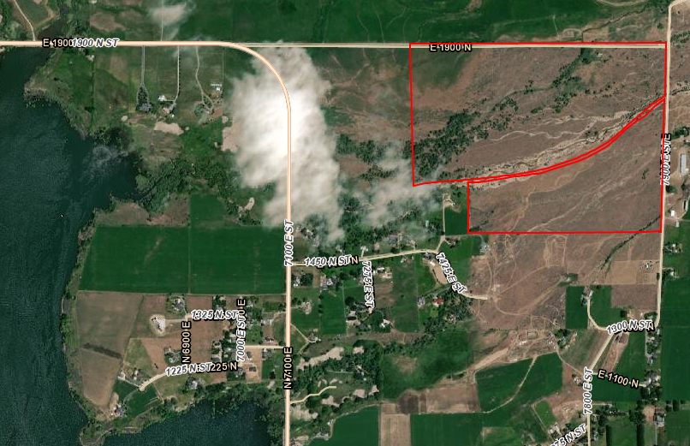

****Exhibit A– Proposed Final Subdivision Plat****

